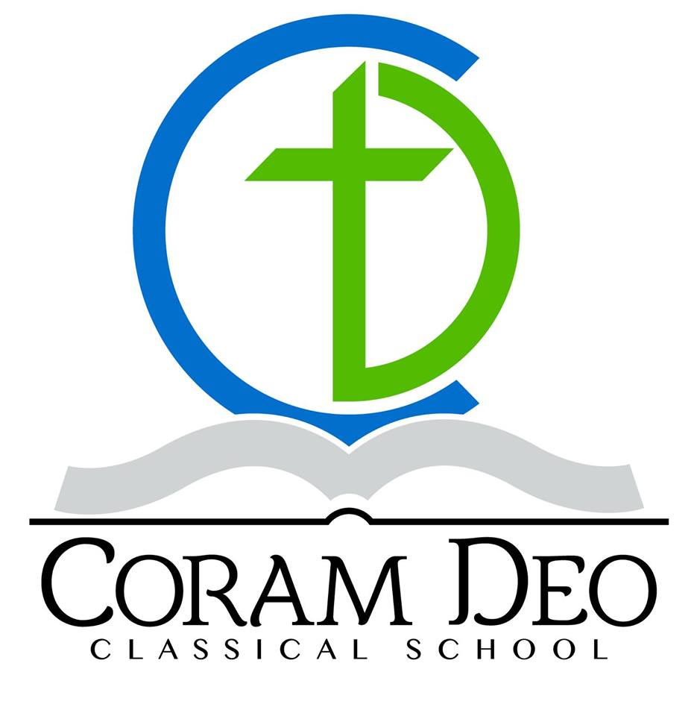
Coram Deo Classical School
605 South 34th Street
Mount Vernon, IL 62864
618.244.9338
coramdeoclassicalschool@gmail.com
www.thecoramdeo.org
Training Students to Transform Their Culture for Christ.

TEACHER JOB DESCRIPTION

Overview

Coram Deo Classical School (CDCS) was founded in 2016 as a Classical Christian school with students in Junior-Kindergarten through 4th grade. CDCS will add one higher grade each year through high school. Our curriculum emphasizes reading and history and celebrates Western Civilization and our Christian heritage.

Coram Deo Classical School classrooms are teacher-centered, expectations are clearly defined, and children are expected to come to school prepared and ready to learn. CDCS teachers foster a love of learning, are compassionate and create an orderly classroom environment. The successful CDCS teacher has a passion for teaching and believes in the Classical tradition as the best way to achieve academic excellence and foster a love of learning in children.

Position Requirements

- Christian: All staff are dedicated followers of Jesus Christ.
- Love: All staff seek to love God supremely and love their neighbor as themselves.
- A passion for Classical education and the traditional classroom model. Must have the experience (personal education or teacher), passion, and skills to successfully teach in such a setting.
- Post-secondary education is preferred.
- Well-organized, able to handle multiple demands efficiently, and effective at leading and managing a classroom of children.
- Implement Memoria Press curriculum and CDCS methodology.
- Support CDCS’s Mission, Vision, Values, and doctrines of faith.

Key Responsibilities

- Create and maintain a nurturing classroom environment that fosters a love of learning in children.
- Lead, teach, and manage a class of 10-14 children.
- Effectively teach the curriculum on a day-to-day basis. CDCS exclusively implements Classical Christian curriculum distributed through Memoria Press.
- Thoroughly prepare each day’s lesson plans & weekly class overview.
- Complete a bi-weekly grade report for each student.
- Be available to meet with parents to discuss student performance or other issues.
- Implement all school policies and procedures.
- Communicate regularly with the School Administrator regarding classroom and student issues.

Work Requirements

1. Reference check.
2. Background Screen.
3. Sign teacher contract for one academic year beginning July 1 through June 30.

Compensation

- School is in session Tuesday through Friday from 8:00 am until 3:30 pm. Additional time spent with students, with lesson preparation and grade management constitutes a 40 hour work week.
- Annual salary starts at $20,000 and increases based on experience and school growth.
- CDCS is in session 35 weeks per year. The salary structure includes Teacher Training Week and time spent either before the school year begins, after it ends or a combination thereof.
- Position reports to Candace Polk, School Administrator.

Coram Deo Classical School is an “At Will” employer and as such we reserve the right to terminate employment for any reason not prohibited by law.

